Project Report II – Cloud Computing

Cloud-Based Distributed Job Processing Platform

Team number: 18
Student names: Yap Zi Yang Irwen, Thang Weng Khong, Muhammed Fakhrurazi Bin Helmi, Tan Yong Chin
3 April 26

Table of Contents
1. Introduction 3
2. Architecture Design and Solutions 5
2.1 System Architecture 5
2.2 Functional Components 5
2.3 Workflow Scenarios 6
2.4 Deployment 7
3. Discussions 8
4. Reflection and takeaways 8
5. Contribution from team members 8
Reference 10
Appendix I 10

Introduction

Cloud computing has enabled the development of scalable and distributed systems that can efficiently handle large volumes of asynchronous workloads. In modern applications, tasks such as code execution, data processing, and background computations are often decoupled from user requests and executed in distributed environments to improve performance and responsiveness.

This project presents the design and implementation of a Cloud-Based Distributed Job Processing Platform using AWS cloud services. The system allows users to submit computational jobs through a web interface or API, which are then processed asynchronously in the cloud. Users are able to monitor job status and retrieve execution results in near real-time, providing a seamless and responsive experience.

The system adopts a hybrid architecture combining both Infrastructure-as-a-Service (IaaS) and serverless computing. The frontend application is hosted on Amazon EC2 instances, which are placed behind an Application Load Balancer (ALB) to distribute incoming traffic and ensure high availability. This enables the system to handle multiple users concurrently while maintaining reliable access to the application interface.

The backend is implemented using serverless AWS services such as AWS Lambda, Amazon API Gateway, Amazon SQS, and DynamoDB, forming an event-driven architecture. This combination allows the system to scale dynamically based on workload while minimizing operational overhead.

The primary objective of this project is to explore and demonstrate key cloud computing concepts, including event-driven architecture, serverless computing, and distributed system design. By leveraging managed cloud services, the system is designed to be scalable, fault-tolerant, and loosely coupled. This approach reflects real-world systems such as job schedulers and cloud-based execution platforms like Google Colab and AWS Batch, which rely on asynchronous processing to handle large workloads efficiently.

One of the key challenges addressed in this project is the need to decouple job submission from job execution while maintaining system reliability and responsiveness. Traditional synchronous systems can suffer from delays and scalability limitations when handling compute-intensive tasks. To overcome this, the proposed system uses a message-driven architecture with Amazon SQS, allowing jobs to be queued and processed independently by worker functions. This improves load handling, enhances fault tolerance, and ensures efficient resource utilization.

In addition, the project considers practical aspects such as system monitoring, debugging, and observability using Amazon CloudWatch, as well as frontend-backend integration through a web-based dashboard. These components are essential in real-world cloud systems, where visibility and reliability are critical.

The project is developed collaboratively by a team of four members, each responsible for a specific subsystem. Yap Zi Yang Irwen is responsible for backend and cloud architecture, including Lambda functions and API Gateway integration. Thang Weng Khong focuses on the queue and database layer, managing Amazon SQS and DynamoDB. Muhammad Fakhrurazi Bin Helmi develops the frontend interface using Next.js, while Tan Yong Chin handles testing, monitoring, and documentation. This division of responsibilities ensures clear ownership while supporting effective system integration.

The scope of this project includes backend system design and implementation, API development for job submission and tracking, frontend deployment on EC2 with load balancing, and system monitoring. Advanced features such as authentication, containerized execution, and real-time updates are identified as potential future enhancements but are beyond the current scope.

Overall, this project demonstrates how modern cloud architectures can integrate both traditional hosting (EC2 with load balancing) and serverless services to build scalable, distributed systems capable of efficiently handling asynchronous workloads.

Architecture Design and Solutions

System Architecture

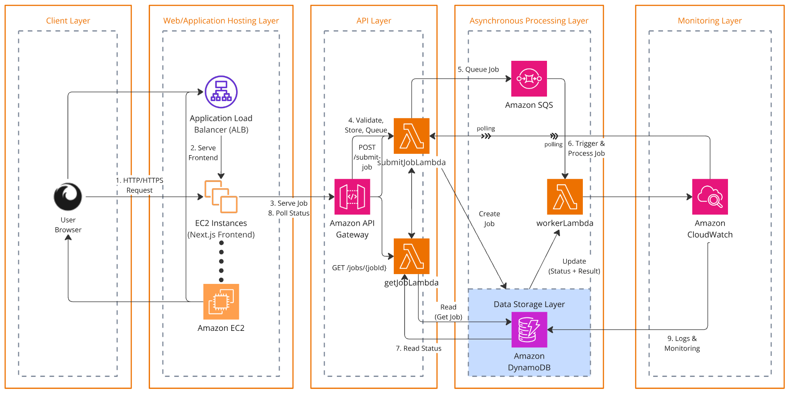

The system is designed using a cloud-native, serverless, event-driven architecture deployed on AWS. It consists of two main layers: a web application hosting layer and a serverless backend processing layer.

In the web hosting layer, users access the application through a browser. Requests are routed through an Application Load Balancer (ALB), which distributes traffic across multiple EC2 instances hosting the frontend application built with Next.js. This ensures scalability and high availability of the user interface.

The backend processing layer is built using managed AWS services. The frontend communicates with Amazon API Gateway, which exposes RESTful endpoints for job submission and status retrieval. API Gateway routes requests to AWS Lambda functions.
When a job is submitted, the submitJobLambda function validates the request, generates a unique job identifier, stores the job metadata in Amazon DynamoDB, and sends the job to Amazon SQS. The queue acts as a buffer, enabling asynchronous and decoupled processing.

The workerLambda function is triggered via SQS (through event source mapping). It processes jobs asynchronously, updates the job status, and stores the results back into DynamoDB. Users can retrieve job status and results through the getJobLambda, which reads data from DynamoDB.

All components are monitored using Amazon CloudWatch, which collects logs and execution metrics for debugging and performance analysis.

Functional Components

The system consists of the following key functional components:

Frontend Application (EC2 + ALB)
Provides a user interface for submitting jobs and viewing results. It communicates with backend APIs and handles user interactions.

Amazon API Gateway
Acts as the entry point for all client requests. It handles routing of HTTP requests to the appropriate Lambda functions and manages API endpoints.

submitJobLambda
Responsible for validating incoming job requests, generating job IDs, storing initial job data, and sending messages to the SQS queue.

Amazon SQS (Simple Queue Service)
Serves as a message queue that decouples job submission from job processing. It ensures reliable delivery and enables asynchronous execution.

workerLambda
Triggered by SQS to process jobs. It performs the core computation logic, updates job status, and stores results in DynamoDB.

getJobLambda
Handles client requests to retrieve job status and results by querying DynamoDB.

Amazon DynamoDB
A NoSQL database used to store job metadata, status, and execution results. It provides low-latency access and scalability.

Amazon CloudWatch
Provides logging and monitoring for all Lambda functions, enabling debugging, performance tracking, and system observability.

Workflow Scenarios

Job Submission Workflow
- The user submits a job through the frontend interface.
- The request is sent via ALB to the EC2-hosted frontend.
- The frontend calls the API Gateway endpoint (POST /submit-job).
- API Gateway invokes submitJobLambda.
- The Lambda function validates the request, creates a job record in DynamoDB, and sends the job to SQS.

Job Processing Workflow
- The job message in SQS triggers workerLambda via event source mapping.
- The workerLambda retrieves the job payload and updates the job status to “processing”.
- The job is executed (or simulated), and the result is generated.
- The job status is updated to “completed” or “failed” in DynamoDB, along with the result.

Job Retrieval Workflow
- The frontend periodically polls the API Gateway endpoint (GET /jobs/{jobId}).
- API Gateway invokes getJobLambda.
- The Lambda function retrieves job status and result from DynamoDB.
- The response is returned to the frontend and displayed to the user.

Deployment

The system is deployed on AWS using a hybrid approach combining Infrastructure-as-a-Service (IaaS) and serverless computing.

The frontend application is hosted on EC2 instances, which are placed behind an Application Load Balancer to ensure scalability, fault tolerance, and efficient traffic distribution. This setup allows multiple instances to serve users concurrently and improves system availability.

The backend is fully serverless, using AWS Lambda functions for compute, API Gateway for API management, SQS for asynchronous messaging, and DynamoDB for data storage. This reduces operational overhead and allows automatic scaling based on demand.

Monitoring and logging are handled using Amazon CloudWatch, which captures logs from all Lambda functions and enables system debugging and performance tracking.

This deployment architecture ensures that the system is:
- Scalable, as both EC2 and Lambda can scale based on load
- Highly available, due to load balancing and managed services
- Cost-efficient, as serverless components incur cost only when used
- Maintainable, with clear separation between frontend and backend components

Discussions

In this section, you shall describe the system functionality and highlight how the system meets some of the requirements related to the following

- Scalability
- Reliability
- Security

You can also share the limitations of the current design and any areas that need improvement in the future.

Reflection and takeaways

Here you can summarize what you and your team have done, what you have learned, and areas for improvement.

Contribution from team members

SN | Name of  Team Member | Student ID | Responsible Components | Contribution (%)
1 | Yap Zi Yang Irwen | 2301345 | Responsible for designing the overall system architecture and implementing core AWS components including Lambda functions and API Gateway endpoints. | 25
2 | Thang Weng Khong | 2301372 | Responsible for setting up and managing Amazon SQS and DynamoDB, including designing the database schema, handling job lifecycle updates and ensuring efficient and consistent data access. | 25
3 | Muhammad Fakhrurazi Bin Helmi | 2303346 | Responsible for building the user interface using Next.js and TailwindCSS, integrating the Monaco editor for job input, implementing API interactions and displaying job status and results. | 25
4 | Tan Yong Chin | 2301359 | Responsible for conducting end-to-end testing, monitoring system behaviour using CloudWatch logs, handling edge cases such as failures and retries, and preparing the final report, diagrams, and documentation. | 25
 |  |  | Total: | 100%

Reference
The references are a list of any sources you have used in your report. Your report should use the standard referencing style following an established referencing format (e.g., IEEE, Harvard, APA, etc.).
- G. Eason, B. Noble, and I. N. Sneddon, “On certain integrals of Lipschitz-Hankel type involving products of Bessel functions,” Phil. Trans. Roy. Soc. London, vol. A247, pp. 529–551, April 1955. (references)

Appendix I

END OF REPORT

